Avanti Learning Centre

2014 - 2016

# P8. Mechanical Properties of Solids

##### TABLE OF CONTENTS

P8. Mechanical Properties of Solids 3

P 8.1. Elasticity I - Introduction 4

Pre-reading Exercise (10 mins + 5 mins GD) 4

In-class Exercise (60 mins + 20 mins GD) 5

Homework (60 mins + 20 MINS GD) 3

P 8.2. Elasticity - II 9

Pre - reading EXERCISE (10 mins + 5 mins GD) 9

In-class Exercise (60 mins + 20 mins GD) 9

Homework (60 mins) 14

## Elasticity I - Introduction

#### Pre-reading Exercise (10 mins + 5 mins GD)

**Solution:** By definition it is a perfectly elastic body.

**Solution:** Stress $=\frac{F_{ }}{A}$ ( where F = tensile force and A = Area of cross section)

$Stress=\frac{mg}{A}=\frac{\left(500kg\right)\left(9.8 m/s^{2}\right)}{\left(0.5×{10}^{-4}m^{2}\right)}$

$${Stress}_{ }=9.8×{10}^{7} N/m^{2}$$

**Solution:** In the region OA, stress $∝$ strain i.e. Hooke’s law holds good

**Solution:** Point B is called as the Yield point. It is also known as the elastic limit.

**Solution:** Point D is called as the breaking point. It represents the ultimate tensile strength of the material.

**Solution:**

Here $l=10m$

$$diameter \left(d\right)=5mm→r=2.5×{10}^{-3}m$$

Young’s Modulus (Y) $=2.4×{10}^{12}\frac{dyne}{cm^{2}}=2.4×{10}^{11}\frac{N}{m^{2}}$

Force $F=10×9.8N=98N$

From definition of Young’s Modulus

$$Δl=\frac{Fl}{AY}=\frac{98×10}{3.14×{\left(2.5×{10}^{-3}\right)}^{2}×2.4×{10}^{11}}=20.8×{10}^{-5}N/m^{2}$$

#### 

#### In-class Exercise (60 mins + 20 mins GD)

**Level 1**

**Solution:** Original length $=5m$

Increase in length $=2 cm=2×{10}^{-2} m$

$∴$ Longitudinal strain $=\frac{Change in length}{Original length}=\frac{2×{10}^{-2}m}{5m}=4×{10}^{-3}$

**Solution:** Cross section area of cylinder $=πr^{2}=π{\left(0.045m\right)}^{2}=6.36×{10}^{-3} m^{2}$

$$Δl=\frac{Fl}{AY}=\frac{\left(8×{10}^{4}×9.8\right)×4}{\left(6.36×{10}^{-3}\right)\left(1.9×{10}^{11}\right)}=25.95×{10}^{-4} m$$

$Δl=2.6 mm$

**Solution:**

$Y=\frac{stress}{strain}=\frac{force}{area}×\frac{1}{strain}$

$$Y=\frac{F}{A×strain}$$

$F=Y×A×strain$

Here the increase in length is 20%. Hence $strain=\frac{∆l}{l}=\frac{20\% of l}{l}=\frac{0.2l}{l}=0.2$

$$F=12×{10}^{10}×5.02×{10}^{-5}×0.2$$

$$F=12.06×{10}^{5}≈12×{10}^{5}N$$

**Level 2**

**Solution:**

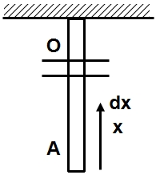As tension is non-uniform along the wire, we have variable stress Consider an infinitesimal element of length $dx$ at a distance $x$ from bottom end $A.$

The tension at this position in the wire $=\frac{mgx}{l}$

Let $dl=$ increase in length of the small element with length $dx$.

$⇒$ strain $=\frac{dl}{dx}$

$⇒ Y=\frac{mgx/lA}{dl/dx} ⇒ dl=mgxdx/YlA$

The total change in length of the wire is the sum of the changes in length of infinite such elements along the wire.

Total charge in length $Δl=\int{dl}=\int_{0}^{l}{\frac{mgxdx}{YlA}}$

$Δl=\frac{mg}{YlA}\frac{l^{2}}{2} ⇒ Δl=\frac{mgl}{2Yπr^{2}}$

$$Note: \frac{Δl}{l}=\frac{stress at mid pt.}{Y}$$

1. 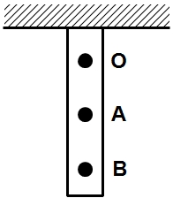

**Solution:** Let $l$ be length of wire required.

Weight of wire $=$ mg $=\left(ρv\right)g$

$$=\left(ρAl\right)g$$

Tension and hence the stress is maximum at the topmost point O.

$T_{o}=mg σ_{0}=\frac{T_{0}}{A}=\left(ρl\right)g$

$σ_{0}=6×{10}^{9}\frac{N}{m^{2}}=9×{10}^{3}×l×9.8 ⇒ \frac{6}{88.2}×{10}^{6}m=6.8×{10}^{4}m$

Here it is evident that the stress on the wire does not depend on the diameter of the wire. Hence, even if the diameter of the wire is doubled, the stress in the wire does not change. Hence the length will remain the same.

This is around 68 km length of wire. This is why the wire does not break on its own in real life situations.



**Solution:**

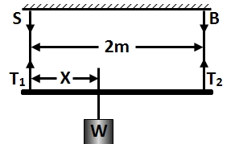(a). As stresses are equal,

$\frac{T_{1}}{A_{1}}=\frac{T_{2}}{A_{2}},$ i.e., $\frac{T_{1}}{T_{2}}=\frac{A_{1}}{A_{2}}=\frac{0.1}{0.2}$ or $T_{2}=2T_{1}$…… (1)

Now for translator equilibrium of the rod, $T_{1}+T_{2}=W$

Which in the light of eqn. (1) gives

$T_{1}=\left(\frac{W}{3}\right)$ and $T_{2}=\left(\frac{2W}{3}\right)$…….(2)

Now if x is the distance of weight W from steel wire, for rotational equilibrium of rod,

$T_{1}x=T_{2}(2-x)$ or $(W/3)x=(2W/3)(2-x)$

i.e. $x=(4/3)m$

(b) As strains are equal,

$\frac{T_{1}}{A_{1}Y_{1}}=\frac{T_{2}}{A_{2}Y_{2}}$ [as strain = $\frac{stress}{Y}$]

So $\frac{T_{1}}{T_{2}}=\frac{A_{1}Y_{1}}{A_{2}Y_{2}}$ or $\frac{T_{1}}{T_{2}}=\frac{0.1×20×{10}^{11}}{0.2×10×{10}^{11}}=1$ i.e., $T_{1}=T_{2}$

So for translator equilibrium of rod, $T_{1}+T_{2}=W$ in the light=t of eqn. (3) yields

$$T_{1}=T_{2}=(W/2)$$

And for rotational equilibrium of rod

$T_{1}x=T_{2}(2-x)$ or $(W/2)x=(W/2)(2-x)$, i.e., $x=1m$

**Solution: $Stress=\frac{Force}{Area}$**

$$Area = \frac{mass per unit length}{density}$$

stress $=\frac{mg}{\left(\frac{m}{l}\right)\left(1/ρ\right)}=\frac{10×980}{0.1\left(\frac{1}{7}\right)}=686N/m^{2}$

**Solution:**

The stretching force developed in the wire due to rotation of the ball is

$$f=m r ω^{2}=1×1×{\left(20\right)}^{2}=400 N$$

$stress in the wire=\frac{force }{area }=\frac{400}{{10}^{-6}}$

$strain in the wire=\frac{{10}^{-3}}{1}={10}^{-3}$

$∴young^{'}s modulus=\frac{stress}{strain}=\frac{400}{{10}^{-6}×{10}^{-3}}$

$=4×{10}^{11}N/{m^{2}}$

Let $ω_{0}$ be the breaking angular velocity, than

$breaking stress=\frac{m r ω_{0}^{2}}{A}=\frac{1×1×{\left(100\right)}^{2}}{{10}^{-6}}$ = ${10}^{10}N/{m^{2}}$

**Solution:**

Let the natural length be $=l$

$Δl=\frac{Tl}{AY}$

$$⇒Δl_{1}= l_{1}-l=\frac{T_{1}l}{AY}$$

$$Δl_{2}= l_{2}-l=\frac{T_{2}l}{AY}$$

$$\frac{l_{1}-l}{l_{2}-l_{ }}=\frac{T_{1}}{T_{2}}$$

$$⇒ l=\frac{l_{1}T_{2}-l_{2}T_{1}}{T_{2}-T_{1}}$$

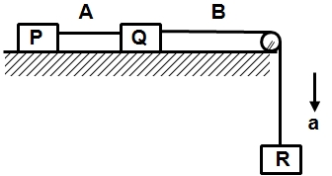**Solution:**

Let the tension in the wire A and B be $t_{A}$ and $T_{B}$ respectively. Writing equations of motion of blocks P, Q and R, we get

$T_{A}=3a…………….(1)$

$T_{B}-T_{A}=3a………(2)$

$3g-T_{B}=3a………(3)$

From equations (1) And (2), we get $T_{B}=2T_{A}$

By equation (1) and (3), $T_{A}-T_{B}=3g=30 Newton$

Or $T_{A}+2T_{A}=30$

Or $T_{A}=10$ N

Now $T_{B}=20N$

We know that

$Longitudinal strain=\frac{Longitudinal stress}{Young^{'}s modulus}$

$Strain in wire A=\frac{{10}/{0.005 cm^{2}}}{2×{10}^{11}N/{m^{2}}}$

$=\frac{10/0.005×{10}^{-4}m^{2}}{2×{10}^{11}N/{m^{2}}}={10}^{-4}$

$Strain in wire B=\frac{20N/{0.005 cm^{2}}}{2×{10}^{11}N/{m^{2}}}=2×{10}^{-4}$

**Solution:**

Given: Elongation of first wire $\left(∆l_{1}\right)=0.1 mm$;

Elongation of second wire $\left(∆l_{2}\right)=0.05mm$ and

area of cross-section of first wire $\left(A_{1}\right)=4mm^{2}$.

We know that Young’s modulus for the wire material is,

$$\left(Y\right)=\frac{F.l}{A_{1}.∆l_{1}}=\frac{F.l}{A_{2}.∆l_{2}}$$

Since both the wires are similar and subjected to the same load, therefore,

$A_{1}.∆l_{1}=A_{2}.∆l_{2}$

$∴A_{2}=\frac{A_{1}∆l_{1}}{∆l_{2}}=\frac{4×0.1}{0.05}=8 mm^{2}$

**LEVEL 3**

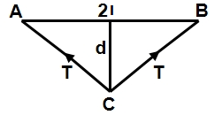**Solution:**

Increase in length = (AC+CB)-2 $l$

= $\left[2\sqrt{{(l}^{2}+d^{2})}-2l\right]$

Longitudinal stress =T/ $πr^{2}$,

(where r is radius of wire).

Longitudinal strain= $\frac{\left[2\sqrt{{(l}^{2}+d^{2})}-2l\right]}{2l}$

Now, Young’s modulus = $\frac{Longitudinal stress}{Longitudinal strain}$ or, $Y=\frac{T}{πr^{2}}×\frac{2l}{\left[2\sqrt{{(l}^{2}+d^{2})}-2l\right]}$

∴ $T=\frac{Y×πr^{2}×\left[2\sqrt{{(l}^{2}+d^{2})}-2l\right]}{2l}$

If d<< $l$, then

$\sqrt{{(l}^{2}+d^{2})}=l{\left(1+\frac{d^{2}}{l^{2}}\right)}^{\frac{1}{2}}=l\left(1+\frac{d^{2}}{{2×l}^{2}}\right)$ ∴ $T=Y×πr^{2}(d^{2}/2l^{2})$

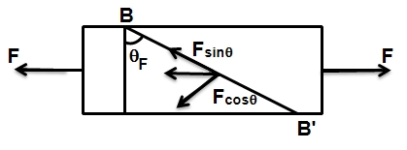**Solution:** The bar of cross sectional area $A$ is shown in the fig. Imagine a cut along the plane $BB'$. Since this section is in equilibrium, the bar on the left must have been exerting a horizontal force $F$ uniformly to the left. This force $F$ has been resolved in two components, $F$ cos $θ$ (normal to the plane $BB’$) and $F$ sin $θ$ (along the plane $BB’$).

(a) Tensile stress= $\frac{Normal force}{area of cross section}$

Here Normal force= $F cosθ$

And area of cross section= $A/cosθ$

$∴$ Tensile stress = $\frac{F cosθ}{A/cosθ}=\frac{F\cos^{2}{θ}}{A}$

(b) Shearing stress = $\frac{Tangential force}{area of cross section}$

= $\frac{F sinθ}{A/cosθ}=\frac{F sinθ\cos{θ}}{A}$

= $\frac{F Sin 2 θ}{A}$

(c) From part (a), the tensile stress is given by

= $\frac{F\cos^{2}{θ}}{A}$

This will be maximum when $\cos^{2}{θ}=1 i.e.$, $θ=0$

(d) Shearing stress= $\frac{F Sin 2 θ}{A}$

This will be maximum when $sin 2{θ}=1$

$2 θ=π/2$, $i.e.$, $θ=π/4$

#### Homework (60 mins + 20 MINS GD)

##### LEVEL 1

**Solution:**

Here we are given that,

Length $l=75cm=0.75m$

Diameter $d=0.13cm=1.3×10^{-3}m$

Hence radius $r=0.65×10^{-3}m$

Area $a=πrl=1.53×10^{-3}m^{2}$

Now, Stress $=\frac{Force}{area}=\frac{8×9.8}{1.53×10^{-3}}=51.24×\frac{10^{3}N}{m^{2}}$

Strain $=\frac{change in length}{original length}=\frac{0.035}{75}=0.005$

Young $=\frac{stress}{strain}=\frac{51.24×10^{3}}{0.005}=10.25×10^{7}N/m^{2}$

**Solution**: Original length $=5m$

Increase in length $=2 cm=2×{10}^{-2} m$

$∴$ Longitudinal strain $=\frac{Change in length}{Original length}=\frac{2×{10}^{-2}m}{5m}=4×{10}^{-3}$

**Solution :**

Here, the force on the wire is equal to the weight of the wire hence

$$F=mass\left(m\right)×accelaration due to gravity\left(g\right)=mg$$

Stress $=\frac{Mg}{πr^{2}}=\frac{0.4×9.8}{3.14×{\left(0.25×{10}^{-3}\right)}^{2}}$

Stress= $19.98×{10}^{6}≈2×{10}^{7} N/m^{2}$

##### LEVEL 2

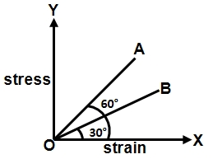**Solution:** Y is clearly the slope of the stress strain graph since Stress = Y strain $\frac{Y_{A}}{Y_{B}}=\frac{\tan{θ_{A} }}{\tan{θ_{B} }}=\frac{tan60}{tan30}=\frac{\sqrt{3}}{1/{\sqrt{3}}}=3⇒Y_{A}=3Y_{B}$

**Solution:**

Let the extension of wire be X for an external force F.

Stress= $\frac{F}{A}, stress=\frac{X}{L},$

$Y=\frac{F/A}{x/L}=\frac{FL}{XA}$

This can be written as F = YAX/L

##### Equivalent force constant = $K=\frac{F}{x}=\frac{YA}{L}$



**Solution:**

1. For a straight line graph, the two quantities should be proportional

$Δl=\frac{Fl}{AY} ⇒ F∝Δl$

Where, $F=$ weight hung.

Hence A is correct.

1. Stress $=$ F/A $=$ Y(Strain)

$=\frac{Y}{l}Δl$

$⇒$ Stress $∝Δl$. Hence B is correct.

$Y=\frac{Stress}{stain}$

$⇒$ stress $∝$ strain

Hence C is correct

Same as A. This is also correct.

1. From 1 we have again,

$Δl=\frac{Fl}{AY} ⇒ F∝Δl$

Where, $F=$ weight hung.

Hence D is also correct.

**Solution:**

1. 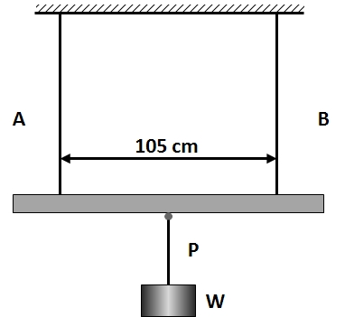Let $x=$ distance of the point $P$ where and weight is suspended from wire $A$.

Let $F_{1}$ and $F_{2}$ be the tensions in $A$ and $B$.

Balancing torques about $P,$ $F_{1}x=F_{2}\left(105-x\right)$

As the rods have equal stress

$\frac{F_{1}}{A_{1}}=\frac{F_{2}}{A_{2}} ⇒ 2F_{1}=F_{2}$

Solving for $x$ we get : $\frac{105-x}{x}=\frac{1}{2}$

$⇒ x=70 cm$ (from A)

1. One equation is same i.e. $F_{1}x=F_{2}\left(105-x\right)$

equal strain $⇒ \frac{Y_{1}A_{1}}{F_{1}}=\frac{Y_{2}A_{2}}{F_{2}}$

$⇒ \frac{F_{1}}{F_{2}}=\frac{2.4}{1.6}×\frac{1}{2}=\frac{3}{4}$

$⇒ \frac{105-x}{x}=3/4$

$⇒ x=60 cm$ (from A)

##### LEVEL 3

**Solution:**

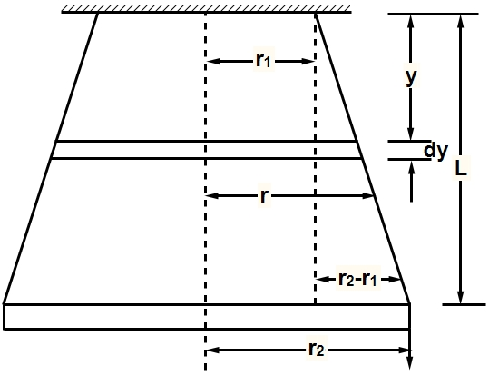

The situation is shown in fig. Let $L$ be the length of the wire. Suppose $r_{1}$ and $r_{2}$ be the radii of the upper and lower ends of the wire respectively. Now the radius $r$ of the wire at a distance $y$ from the upper end is given by

$$r=r_{1}\left(r_{2}-r_{1}\right) y/L$$

Stress at a distance $y$ is given by

$$\frac{Mg}{πr^{2}}=\frac{Mg}{π{\left[r_{1}+\left(r_{2}-r_{1}\right) y/L\right]}^{2}}$$

Corresponding strain

$$=\frac{stress}{Young^{'}s modulus}=\frac{Mg}{Y π{\left[r_{1}+\left(r_{2}-r_{1}\right) y/L\right]}^{2}}$$

Consider a very small part $dy$ of the wire. Extension $Δl$ is given by

$$Δl=strain×dy=\frac{M g dy}{Y π{\left[r_{1}+\left(r_{2}-r_{1}\right) y/L\right]}^{2}}$$

Total extension in the length $L$ of the wire

$$l=\int_{0}^{L}{Δl}=\int_{0}^{L}{\frac{M g dy}{Y π{\left[r_{1}+\left(r_{2}-r_{1}\right) y/L\right]}^{2}}}$$

$$=\frac{Mg}{Y π}\int_{0}^{L}{\frac{M g dy}{{\left[r_{1}+\left(r_{2}-r_{1}\right) y/L\right]}^{2}}}$$

$$=\frac{3.14×9.8}{\left(2×{10}^{11}\right)\left(3.14\right)}\int_{0}^{L}{\frac{ dy}{{\left[(5.0×{10}^{-4}+\left(4.8×{10}^{-4}\right) y/10.0\right]}^{2}}}$$

$$=4.9×{10}^{-3}\int_{0}^{10}{\frac{dy}{{(5.0+0.48 y)}^{2}}}$$

$$=-\frac{4.9×{10}^{-3}}{0.48}{\left[\frac{1}{5.0+0.48 y}\right]}_{0}^{10}$$

$$={10}^{-3}m.$$

On interchanging the ends, the change in length remains the same.

**Solution:** Sol: Stretching force=tension in the wire

=4kg wt. =4000 $×$ 980 dyne

Cross sectional area of wire = $πr^{2}$ = $π{\left(0.05\right)}^{2} cm^{2}$

Tension per unit area= $\frac{4000×980 dyne}{π{\left(0.05\right)}^{2}cm^{2}}$

Let the extension produced is $Δl$ cm

Linear strain = $\frac{change in length }{original length}$ = $\frac{Δl}{400}$

We know that

Young’s modulus = $\frac{linear stress}{linear strain}$

$∴$ Linear strain = $\frac{linear stress}{Young^{'}s modulus}$

$$\frac{Δl}{400} =\frac{4000×980}{π{\left(0.05\right)}^{2}}×\frac{1}{9.8×{10}^{11}}=0.2038 cm$$

**Solution:**

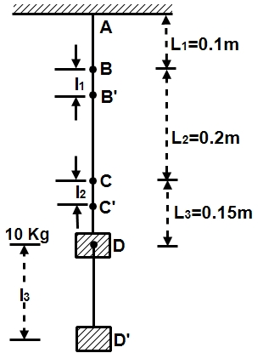The situation is shown in fig

We know that $Δl =\frac{MgL}{YA}$

$for rod AB {Δl}_{1}=\frac{10×9.8×0.1}{2.5×{10}^{10}×{10}^{-4}}$

$=3.92×{10}^{-6} m$

$for rod BC Δl_{2}=\frac{10×9.8×0.2}{4.0×{10}^{10}×{10}^{-4}}$

$=4.90×{10}^{-6}m$

$for rod CD {Δl}_{3}= \frac{10×9.8×0.15}{10×{10}^{10}×{10}^{-4}}$

$=14.7×{10}^{-6}m$

Displacement of B

$BB^{'}={Δl}_{1}=3.92×{10}^{-6}m$

Displacement of C

$={Δl}_{1}+{Δl}_{2}$

$=3.92×{10}^{-6}m+4.90×{10}^{-5}m$

$=8.82×{10}^{-6}m$

Displacement of D

$={Δl}_{1}+{Δl}_{2}+{Δl}_{3}$

$=3.92×{10}^{-6}m+4.90×{10}^{-6}m+14.7×{10}^{-6}m$

$=23.52×{10}^{-6}m$

## Elasticity - II

#### Pre - reading EXERCISE (10 mins + 5 mins GD)

**Solution:** Energy stored per unit volume $=\frac{1}{2} \left(\frac{F}{A}\right)\left(\frac{l}{L}\right)=\frac{FΔl}{2AL}$

**Solution:**

$$B=\frac{1}{compressibility}=0.25×{10}^{5} atm$$

$\frac{P}{ΔV/V}=\frac{100×100}{ΔV}$

$⇒ ΔV=\frac{{10}^{4}×4}{{10}^{5}}cc=0.4cc$

#### In-class Exercise (60 mins + 20 mins GD)

**LEVEL 1**

**Solution:**

Here $ΔP=100.0$ atm $=100.0×1.013×{10}^{5} Nm^{-2}$

$ΔV=100.5-100.0=0.5$ litre

$V=100.0$ litre

$∴ B=\frac{VΔP}{ΔV}=\frac{100.0×1.013×{10}^{5} Nm^{-2}}{0.5}=2.03×{10}^{9} Nm^{-2}$

**Solution**:

Work done $=\frac{1}{2}×\left(stress×strain×volume\right)$

$=\frac{1}{2}×\left(Y×strain\right)×strain×volume$

$=\frac{1}{2}×Y×{\left(strain\right)}^{2}×volume$

$=\frac{1}{2}×Y×{\left(\frac{x}{L}\right)}^{2}×volume$

$=\frac{1}{2}×Y×{\left(\frac{x}{L}\right)}^{2}×AL=\frac{Yx^{2}A}{2L}$

**Solution:** Shear stress $=\frac{Tangential force}{Area of face}=\frac{0.5}{15×{10}^{-4}}=333 0N/m^{2}$

Shear strain $=θ=\frac{Δx}{y}=\frac{\left(displacement\right)}{height}=\frac{0.4}{3}=0.133$

$η$ (Shear modulus) $=\frac{\left(shear stress\right)}{\left(shear strain\right)}=\frac{333}{0.133}=2500N/m^{2}$

**Solution :** Volume stress $=p=2×{10}^{7} N/m^{2}$

Volume strain $=\frac{ΔV}{V}=\frac{ΔV}{{\left(0.04\right)}^{3}}$

$B$ (bulk modulus) $=-\frac{p}{\frac{Δv}{v}}$

$$⇒ ΔV=\frac{-pV}{B}=\frac{-\left(2×{10}^{7}\right){\left(0.04\right)}^{3}}{1.25×{10}^{11}}$$

$$=1.024×{10}^{-8} m^{3}$$

$$=-10.24 mm^{3}$$

**LEVEL 2**

**Solution:** Energy stored per unit volume = $\frac{1}{2}(stress×strain)$. And,

$stress=Young’s modulus× strain=Yϵ$.

Therefore, $energy stored per unit volume=\frac{1}{2}Yϵ^{2}$

**Solution:**

This case is similar to a wire elongating longitudinally. There we have seen the tension in the wire follows a relation, $F=kx$ just like a spring. Similarly, this behaves like a spring where $τ=kθ,$

From our equation,

$$τ=\frac{πηr^{4}}{2l}θ$$

$$k=\frac{πηr^{4}}{2l}$$

Hence, $k_{1}θ_{1}=k_{2}θ_{2}$ since torque is constant.

Therefore,

$$\frac{πηr_{1}^{4}}{2l_{1}}.θ_{1}=\frac{πη{\left(r_{2}\right)}^{4}}{2.\left(l_{2}\right)}.θ_{2}$$

$$\frac{πηr^{4}}{2l}.θ_{1}=\frac{πη{\left(2r^{ }\right)}^{4}}{2.\left(2l\right)}.θ_{2}$$

$$⇒ θ_{1}=8θ_{2}$$

**Solution:** The increase in energy of a brass bar will be equal to work done for compressing it. The work done is given by

$$W=F.l$$

Where $F$ =force applied on the bar and

$l$ =increase in its length.

We know that $Y=\frac{F/A}{l/L}=\frac{FL}{Al}, i.e., l=\frac{FL}{AY}$

$W=\frac{1}{2}F×\frac{FL}{AY}=\frac{F^{2}L}{2A Y}$

Here, $F=5kg wt=5×9.8 newton$,

$L=0.2 m, A=1.0 cm^{2}=1.0×{10}^{-4}m^{2}.$

$W=\frac{{\left(5×9.8\right)}^{2}×0.2}{2×(1.0×{10}^{-4}×1.0×{10}^{11}}$

= $24.01×{10}^{-6}$ joules

**Solution:**

We know that

Elastic energy per unit volume = $\frac{1}{2}×stress×strain$

Here, strain = $α$

And $Y=\frac{stress }{strain } or stress=Y×strain$

$∴stress=Y×α$

Now , elastic energy per unit volume

$$=\frac{1}{2}×\left(Y×α\right)×α=\frac{1}{2}.Yα^{2}$$

**Solution:** Consider a wire of length $L$ and area of cross-section $A$. Let $l$ be the increase in the length when a stretching force $F$ is applied. The workdone $dW$ in increasing the length $dl$ is given by

$dW=F.d$.

The total work done in increasing the length $l$ is given by

$W=\int_{0}^{l}{F.dl}$…………..(1)

We know that $Y=\frac{stress}{strain}=\frac{F/A}{l/L}$

∴ $F=\frac{YA l}{L}$…………….(2)

Substituting the value of $F$ from equation (2) in equation (1), we get

$W=\int_{0}^{l}{\frac{Y Al}{L}}dl=\frac{YA}{L}{\left(\frac{l^{2}}{2}\right)}_{0}^{l}=\frac{YA l^{2}}{2L}$

Substituting the given values, we have

$$W=\frac{2×{10}^{11}×{10}^{-6}×{\left(4×{10}^{-3}\right)}^{2}}{2×1.5}$$

= 1.066 joules.

**LEVEL 3**

1. 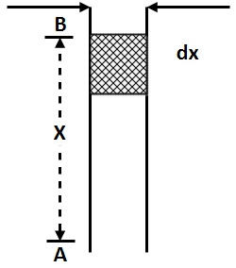

**Solution:** Consider an element of wire of length $dx$ at a height $x$ from

the ground as shown in figure.

Load on $dx$ =weight of the part $AB$

= $\left(Axρ\right)g$

If $e$ be the elongation of element $dx,$ then

$Y=\frac{stress}{strain}=\frac{\left(Axρ\right)g/A}{e/dx}$

$$∴ e=\frac{ρ g x dx}{Y}$$

Stretched length = $dx+e=dx+\frac{ρ g x dx}{Y}$

= $\left(1+\frac{ρ g x}{Y}\right)dx$

Entire length = $\int_{0}^{H}{\left(1+\frac{ρ g x}{Y}\right)dx}$

= $H+\frac{ρ g}{Y}{\left[\frac{x^{2}}{2}\right]}_{0}^{H}=H+\frac{ρ g}{Y}×\frac{H^{2}}{2}$

= ${10}^{3}+\frac{9×{10}^{3}×9.8}{1.2×{10}^{11}}×\frac{{10}^{6}}{2}$

$$\left[∵H=1km={10}^{3}m\right]$$

$$={10}^{3}+0.3675$$

$∴$ Increase in length = 0.3675m.



**Solution:** At surface of ocean $P_{0}=1$ atm

$$ρ_{0}=1025 kg/m^{3}$$

Or, $1m^{3}$ volume has mass $=1025 kg$

$B=-\frac{PV}{ΔV}$

$∴ P=$ Changes in pressure $=\left(700-1\right)$ atm $=699$ atm

$ΔV=$ Change in volume,

$$V=1m^{3}$$

$∴ ΔV=\frac{\left(699×1.01×{10}^{5}\frac{N}{m^{2}}\right)×\left(1m^{3}\right)}{2.0×{1.0}^{9}\frac{N}{m^{2}}}$

$ΔV=-0.0353 m^{3}$

$∴ ρ^{'}=$ New density of water $=\frac{m}{V+ΔV}$

$ρ^{'}=\frac{1025kg}{1.00 m^{3}-0.0353 m^{3}}=\frac{1025kg}{0.9647m^{3}}=1062.51\frac{kg}{m^{3}}$

Water gets compressed by about $2-3\%$ at the ocean bed due to very high pressure.

#### Homework (60 mins)

##### LEVEL 1

**Solution:**

Stress= $\frac{Force}{Area}$

The shear is on the area where shear force acts, which is the curved surface area of the punched material. Hence area = $2πrt$

$$F=SA=S×2πr^{ }t$$

$={10}^{8}×2×3.14×1×{10}^{-3}×2×{10}^{-3}$

$={10}^{2}×4×3.14$

$$F=1256 N$$

**Solution:**

$$Work done=\int_{0}^{Δl}{F.ds}$$

Where F is the elastic force and s is the elongation.

$$Force=\frac{YAs}{l}$$

$$W=\int_{0}^{Δl}{\frac{YAs}{l}.ds}$$

Hence $W=\frac{YA}{l}{\left.\frac{s^{2}}{2}\right]}_{0}^{Δl}$

Hence,

$=\frac{1}{2}\frac{YA}{l}{Δl}^{2}$

If we compare this expression with that of a spring $W=\frac{1}{2}kx^{2}$, then $k=YA/l$

Hence, the work done = $\frac{1}{2}\frac{2×{10}^{10}×{10}^{-6}}{0.5}×{{(10}^{-3})}^{2}=2×{10}^{-2}J$

**Solution:**

We know that, the extension produced in case of a cylindrical wire is directly proportional to the length (L) of the wire and inversely proportional to the area of cross-section,

Hence,

$x∝\frac{L}{D^{2}}$

So for large extension we need longer wire but of lesser cross-section area,

Therefore, d is the correct answer.

##### LEVEL 2

**Solution:**

Young’s modulus of elasticity is given by

$Y=\frac{stress}{strain}=\frac{F/A}{l/L}=\frac{FL}{lA}=\frac{FL}{l\left(\frac{πd^{2}}{4}\right)}$

Substituting the values, we get

$Y=\frac{50×1.1×4}{\left(1.25×{10}^{-3}\right)×π×{\left(5.0×{10}^{-4}\right)}^{2}}$

$=2.24×{10}^{11} N/m^{2}$

Now, $\frac{ΔY}{Y}=\frac{ΔL}{L}+\frac{Δl}{l}+2\frac{Δd}{d}$

$=\left(\frac{0.1}{110}\right)+\left(\frac{0.001}{0.125}\right)+2\left(\frac{0.001}{0.05}\right)=0.0489$

$ΔY=\left(0.0489\right)Y$

$=\left(0.0489\right)×\left(2.24×{10}^{11}\right)N/m^{2}$ $=1.09×{10}^{10} N/m^{2}$

**Solution:**

We have seen that the restoring force is given as,

$$τ=\frac{1}{2}\frac{πηr^{4}}{l}θ$$

In equilibrium, we have seen that,

Applied torque $=$ Restoring torque.

$Fr=\frac{πηr^{4}}{2l}θ$ $⇒ θ=\frac{2×1.5×4×{10}^{5}}{π\left(6×{10}^{10}\right){\left(0.02\right)}^{3}}=0.796$ Radians $\left(θ≈45.5°\right)$

**Solution:** Work done in producing the extension

$=\frac{1}{2}×stretching force×extension$

$=\frac{1}{2}×5×9.8×0.4$

$$Work done = 9.8 Joules$$

##### LEVEL 3



**Solution**: a. Consider an element of length $dx$ at a distance $x$ from the fixed end. Let $dU$ be the energy stored in the element of length $dx$. Then

$$du=\frac{1}{2}×stress×strain×volume$$

$$=\frac{1}{2}×\frac{m\left(l-x\right)g}{lA}×\frac{stress}{Y}×A.dx$$

$$=\frac{1}{2Y}{\left[\frac{mg\left(l-x\right)}{lA}\right]}^{2}×A dx$$

$$∴U=\frac{1}{2Y}\frac{m^{2}g^{2}}{l^{2}A}\int_{0}^{l}{\left(l^{2}-2lx+x^{2}\right)dx}$$

$$=\frac{m^{2}g^{2}}{2Y l^{2 }A} \left[l^{2}.l-l^{3}+\frac{l^{3}}{3}\right]=\frac{m^{2}g^{2}l^{3}}{6Yl^{2}A}$$

$$=\frac{m^{2}g^{2}l}{6 Y A}=\frac{{\left(π r^{2} lρ\right)}^{2} g^{2} l}{6 Y (π r^{2})}=\frac{π r^{2}ρ^{2}g^{2}l^{3}}{6 Y}$$

b. $dU=\frac{1}{2}×stress×strain×volume$



$$=\frac{1}{2}×\left(strain×Y\right)×strain×volum$$

$=\frac{1}{2}Y×{\left(strain\right)}^{2}×volume$

$=\frac{1}{2}Y{\left(\frac{∆l}{l}\right)}^{2}×π r^{2} l.$

**Solution:**

Here strain $=\frac{0.03}{1.5}$

If A be the area of cross section of the wire, then

$stress=\frac{2×9.8}{A} n/{m^{2}}$

$∴Young^{'}s modulus, Y= \frac{stress }{strain }$

$=\frac{2×9.8}{A}×\frac{1.5}{0.03}$

$=\frac{980}{A} n/{m^{2}}$

After falling the mass through a distance 1.5 m, the velocity is given by

$v^{2}=2×9.8×1.5.$

$∴Kinetic energy=\frac{1}{2}×2 (2×9.8×1.5)$

$=29.4J$

Now the wire will be stretched. Let $Δl$ be the increase in length, than the strain is given by ( $Δl$/1.5)

$∴Tension in the string=Y×A×Strain$

$=\frac{980}{A}×A×\frac{Δl}{1.5}$

$=\frac{980Δl}{1.5}$

Now work done $=\frac{1}{2}.F.Δl$

$=\frac{1}{2}.\frac{980l^{2}}{1.5}=\frac{980l^{2}}{3} joule$

$Loss of potential energy=2×9.8×l joule$

=19.6 $Δl$ joule

$Loss of kinetic energy=29.4 joule$

$∴\frac{980 {Δl}^{2}}{3}=29.4+19.6 Δl$

Solving it for $Δl$ and taking positive value, we get $Δl$ =0.33 so the mass comes to rest at 1.5+0.33=1.83m below A.

**Solution:**

Maximum stress lies in stepped bar in the portion of lesser area $\left(5 cm^{2}\right)$

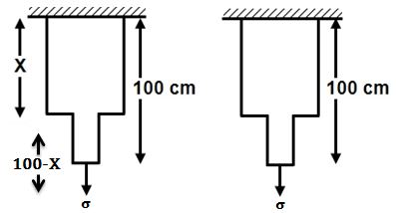For the stress $σ$ in lesser area, the stress in large cross-section $=\frac{σA/2}{A}=\frac{σ}{2}$

Strain energy of stepped bar –

$=\frac{σ^{2}}{2y}×5×\left(100-x\right)+{\left(\frac{σ}{2}\right)}^{2}\frac{1}{2y}×10×x$

$=\frac{σ^{2}}{2y}\left[500-5x+2.5x\right]$

$=\frac{σ^{2}}{2y}\left[500-2.5x\right]$

Stain energy of uniform bar

$=\frac{σ^{2}}{2y}×10×100$

As per given condition

$\frac{σ^{2}}{2y}\left[500-2.5x\right]=\frac{40}{100}×\frac{σ^{2}}{2y}×10×100$

$500-2.5x=400→x=40cm$

**Objective Questions:**

**Solution: $l∝\frac{1}{r^{2}}$** if radius of the wire is doubled than increment in length will become $\frac{1}{4}$ times i.e. $\frac{12}{4}=3mm$

**Solution:** If density of the material increase then more force (stress) is required for same deformation i.e. the value of Young’s modulus increase.

1. 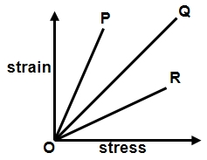

**Solution:** As stress is shown on x-axis and strain on y-axis

So we can say that $Y=\frac{stress }{strain}= cot{θ=\frac{1}{\tan{θ}}=\frac{1}{slope}}$

So elasticity of wire P is minimum and of wire R is maximum.

1. 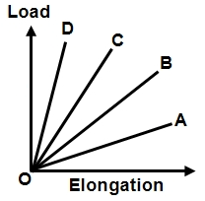

**Solution: $Δl=\frac{FL}{AY} ∴ Δl∝\frac{1}{r^{2}} (Y,L and F are constant)$**

i.e. for the same load , thickest wire will show minimum elongation. So graph D represent the thickest wire

1. 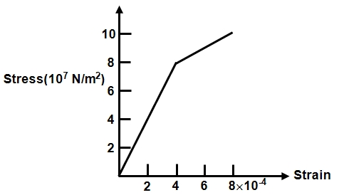

**Solution:** Young’s modulus is defined only in elastic region

$Y=\frac{stress}{strain}=\frac{8×{10}^{7}}{4×{10}^{-4}}=2×{10}^{11} N/{m^{2}}$

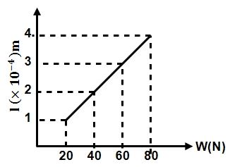**Solution:** Young’s modulus is $Y=\frac{L}{Δl}.\frac{W}{A}$

$Δl=\left(\frac{L}{YA}\right).W$

i.e. graph is a straight line passing through origin, the slope of which is $\frac{Δl}{YA}$.

$∴$ Slope $=\left(\frac{Δl}{YA}\right)$

$∴ Y=\left(\frac{Δl}{A}\right)\left(\frac{1}{slope}\right)$

$$=\left(\frac{1.0}{{10}^{-6}}\right)\frac{\left(80-20\right)}{\left(4-1\right)×{10}^{-4}}$$

$=2.0×{10}^{11}N/m^{2}$

**Solution :**

$W=\frac{1}{2}Kx^{2}$

Here, since $F=kx$

And $Y=\frac{Fx}{AL}$ for displacement $x$ we have,

$$K=\frac{YA}{L}$$

$∴ W=\frac{1}{2}\left(\frac{YA}{L}\right)x^{2}$

1. 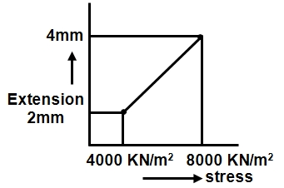

**Solution:** From the definition of Young’s modulus,

$Δl=\frac{FL}{AY}$

$\frac{Δl}{(F/A)}=\frac{L}{Y}=$ Slope of curve

$$\frac{L}{Y}=\frac{\left(4-2\right)×{10}^{-3}}{4000×{10}^{3}}$$

given $L=1m$

$$∴Y=\frac{4000×{10}^{3}}{2×{10}^{-3}}=2×{10}^{9} N/m^{2}$$

**Solution:** Energy stored per unit volume = $\frac{1}{2}×stess×strain$

$=\frac{1}{2}×Young^{'}s modulus×{\left(strain\right)}^{2}=\frac{1}{2}×Y×x^{2}$

**Solution:** Potential energy stored in the rubber cord catapult will be converted into kinetic energy of mass.

$\frac{1}{2} mv^{2}=\frac{1}{2} \frac{YA(Δ{l)}^{2}}{L}⇒v=\sqrt{\frac{YA(Δ{l)}^{2}}{mL}}$

$=\sqrt{\frac{5×{10}^{8}×25×{10}^{-6}×{\left(5×{10}^{-2}\right)}^{2}}{5×{10}^{-3}×10×{10}^{-2}}}=250 m/s$

**Solution:** Bulk Modulus

$B=-\frac{P}{-∆V/V}=-\frac{hρg}{-∆V/V}=-\frac{200×{10}^{3}×10}{-0.1×100}=2×{10}^{9}$

**Solution:** If side of the cube is L then $V=L^{3}⇒\frac{dV}{V}=3\frac{dV}{V}$



$∴\% change in volume=3×(\% change in length)$

$=3×1\%=3\%∴Bulk strain \frac{∆V}{V}=0.03$

**Solution: $K=-\frac{∆p}{{∆V}/V}=-\frac{\left(1.165-1.01\right)×{10}^{5}}{{-10}/{100}}=\frac{0.155×{10}^{5}}{1/{10}}$**

$=1.55×{10}^{5}$ Pa.

**Solution:** Twisting couple $τ=\frac{πηr^{4}θ}{2l}$

If material and length of the wire A and B are equal and equal twisting couple are applied then

$θ∝\frac{1}{r^{4}}∴\frac{θ_{1}}{θ_{2}}={\left(\frac{r_{2}}{r_{1}}\right)}^{4}$

**Solution:** shearing strain $ϕ=\frac{x}{L}=\frac{0.02cm}{10cm}∴ϕ=0.002$

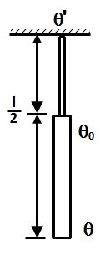



**Solution: $τ=C.θ=\frac{πηr^{4}θ}{2L}=constant in this case$**

⇒ $\frac{πηr^{4}(θ-θ_{0})}{2l}=\frac{πη{\left({ r}/2\right)}^{4}(θ_{0}-θ^{'})}{2\left(l/2\right)}$

$⇒\frac{(θ-θ_{0})}{2}=\frac{θ_{0}}{16}⇒θ_{0}=\frac{8}{9}θ$

**Solution: $U=\frac{1}{2} FΔl=\frac{F^{2}L}{2AY}$**

$U α\frac{L}{r^{2}} \left(F and Y are constants\right)$

$∴ \frac{U_{A}}{U_{B}}=\left(\frac{L_{A}}{L_{B}}\right)×{\left(\frac{r_{B}}{r_{A}}\right)}^{2}=\left(3\right)×{\left(\frac{1}{2}\right)}^{2}=\frac{3}{4}$

**Solution:** Energy per unit volume = $\frac{{\left(stress\right)}^{2}}{2Y}$



$$\frac{E_{1}}{E_{2}}=\frac{Y_{2}}{Y_{1}}\left(stress is constant\right)$$

$$∴\frac{E_{1}}{E_{2}}=\frac{3}{2}$$

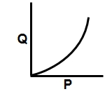**Solution:** Graph between applied force and extension will be straight line because in elastic range.

Applied force $∝$ extension

But the graph between extension and stored elastic energy will be parabolic in nature as,

$$U=1/2 kx^{2}or U∝ x^{2}$$

**Solution:**

$Δp=\frac{Mg}{A}$

$\left|\frac{ΔV}{V}\right|=\frac{Δp}{B}=\frac{Mg}{AB}$

Now as, $V=\frac{4}{3}πR^{3}$ or $V∝R^{3}$

$∴ \frac{ΔV}{V}=3\left(\frac{ΔR}{R}\right)$

$\left(\frac{ΔR}{R}\right)=\frac{1}{3} \left(\frac{ΔV}{V}\right)$..... (i)

$∴$ From Eq. (i)

$$\frac{ΔR}{R}=\frac{Mg}{3AB}$$